**Lab 6**

**If – else and Switch case**

**Name-Surname**………………………………......**Student No**........................................**Section (LAB)**……………

**Lab instruction**

1. Open VS code or JAVA IDE in your computer.
2. Create a new java class name TestBooleanOperators.java, then write the following code.

import java.util.Scanner;

public class TestBooleanOperators {

public static void main(String[] args) {

// Create a Scanner

Scanner input = new Scanner(System.in);

// Receive an input

System.out.print("Enter an integer: ");

int number = input.nextInt();

if (number % 2 == 0 && number % 3 == 0)

System.out.println(number + " is divisible by 2 and 3.");

if (number % 2 == 0 || number % 3 == 0)

System.out.println(number + " is divisible by 2 or 3.");

if (number % 2 == 0 ^ number % 3 == 0)

System.out.println(number +

" divisible by 2 or 3, but not both.");

}

}

This program will test an integer number with three conditions.

1. The number is remainder (%) by 2 equal 0 *and* remainder (%) by 3 equal 0. Example 6, 12, 18, 24…

2. The number is remainder (%) by 2 equal 0 *or* remainder (%) by 3 equal 0. Example 2,3,4,6,8…

3. The number is remainder (%) by 2 equal 0 *or* remainder (%) by 3 equal 0. *But not both*. Example 2,3,8,9

3. Save and test the program by difference inputs.

4. The quadrant in which a line drawn from the origin resides is determined by the angle that the line makes with the positive X axis as follows:

|  |  |
| --- | --- |
| **Angel from the Positive X** | **Quadrant** |
| **Between 0 and 90 degrees** | **I** |
| **Between 90 and 180 degrees** | **II** |
| **Between 180 and 270 degrees** | **III** |
| **Between 270 and 360 degrees** | **IV** |

Using this information, write a Java program that accepts the angle of the line as user input and determines and displays the quadrant appropriate to the input data. (Note: If the angle is exactly 0, 90, 180, or 270 degrees, the corresponding line does not reside in any quadrant but lies on an axis.)

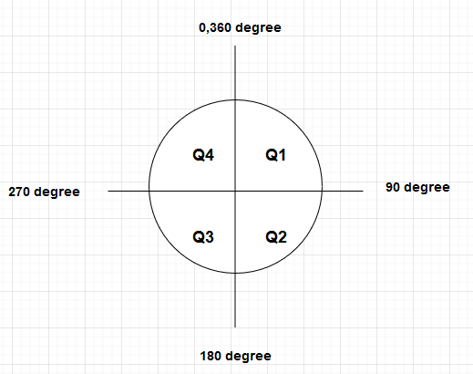

**\*\*\*\*\*\*\*\*\*\*\*\*\*\*\*\*\*\*\*\*\*\*\*\*\*\*\*\*\*\*\*\*\*\*\*CHECK POINT #1\*\*\*\*\*\*\*\*\*\*\*\*\*\*\*\*\*\*\*\*\*\*\*\*\*\*\*\*\*\*\*\*\*\*\*\*\*\*\*\***

5. Write a Java program to sort three integers. The integers are enter from input dialog and store in variables **num1, num2, and num3,** respectively*. The program sort number so that* ***num1≤num2≤num3.***

**\*\*\*\*\*\*\*\*\*\*\*\*\*\*\*\*\*\*\*\*\*\*\*\*\*\*\*\*\*\*\*\*\*\*\*CHECK POINT #2\*\*\*\*\*\*\*\*\*\*\*\*\*\*\*\*\*\*\*\*\*\*\*\*\*\*\*\*\*\*\*\*\*\*\*\*\*\*\*\***

6. Create a Java program Calculator.java

import java.util.Scanner;

public class Calculator {

    public static void main(String[] args) {

      // Create a Scanner

      Scanner input = new Scanner(System.in);

      System.out.println("If x = 50 and y = 2");

      System.out.println("Please select the operator 1.plus 2.subtract 3.multiply 4.division");

      System.out.print("Enter:");

      double answer = 0;

      int x = 50;

      int y = 2;

      int menu = input.nextInt();

      switch (menu) {

        case 1:answer = x+y;

            System.out.print("Answer is "+answer);

                break;

        case 2:answer = x-y;

            System.out.print("Answer is "+answer);

                break;

        case 3:answer = x*y;

            System.out.print("Answer is "+answer);

                break;

        case 4:answer = x/y;

            System.out.print("Answer is "+answer);

                break;

        default:

          System.out.println("You put invalid choice");

              break;

        }

    }

}

7. Compile and Run program.

8.Draw a flowchart of this program

**\*\*\*\*\*\*\*\*\*\*\*\*\*\*\*\*\*\*\*\*\*\*\*\*\*\*\*\*\*\*\*\*\*\*\*CHECK POINT #3\*\*\*\*\*\*\*\*\*\*\*\*\*\*\*\*\*\*\*\*\*\*\*\*\*\*\*\*\*\*\*\*\*\*\*\*\*\*\*\***

--------------------------------------------End of Lab-----------------------------------------------